**CZ2006 Lab**

Github link: <https://github.com/Zero-Ice/CZ2006_DogGo>

**Application name** : My PetDogGo

**Data & API**

<https://data.gov.sg/dataset/weather-forecast>

The data in the above links read at every 30mins interval.

Forecast uses string such as : Partly Cloudy, Moderate Rain and etc

<https://data.gov.sg/dataset/realtime-weather-readings>

Readings every 1minute in degrees celsius

# Project Mission Statement

My PetDogGo application aims to aid first time dog owners by providing them with information on the best time to walk their Dogs. This application ensures that users will have the best experience while walking their Dogs at the application’s suggestions.

# Elicit functional requirements

The application must be able to display the weather temperature 2hours before and future.

The application must be able to display the weather forecast 2hours before and future.

The application must be able to calculate and suggest the perfect time to walk the dogs.

Notification when & what to feed/clinic visit/walk

The application must not suggest when the time is not within the range set by the users.

Dog profiles to keep track of your dogs and display them.

Display useful links and hotlines

**Atomic Requirements**

1. The forecast will display temperature and weather
   1. It will display the temperature
      1. It must be displayed in degree celsius (29.2)
      2. It must display 2hours of history of temperature
      3. It must display 2hours of forecast of temperature
   2. It will display the weather
      1. It must be displayed in categories( Partly Cloudy, Moderate Rain)
      2. It must display 2hours of history of weather
      3. It must display 2hours of forecast of weather
2. Should I walk my dog now function
   1. If both the weather and temperature are right
      1. It must suggest the user that they are able to walk their dogs
   2. If either the weather or temperature are not right (Too hot or it's about to rain soon)
      1. It must inform the user that they should not walk their dogs
3. The dog profile should consist of information about the dogs
   1. The profile must consist of the dog's name
   2. The profile must consist of the dog's picture
   3. The profile must consist of the dog's breed
   4. The profile must consist of the dog's favourite food
4. Useful Links & Hot line
   1. The useful links & hotline should contain
      1. The links must be displayed in hyperlink format
      2. The numbers must be displayed in hyperlink format
5. Settings
   1. Notification settings
      1. It must display the current notification timing
         1. It must displayed in HHMM to HHMM
   2. Dog Profile Settings
      1. A button for user to add or remove information
         1. Must allow the user to edit the dog profile
         2. Must allow the user to add the dog profile
         3. Must allow the user to delete the dog profile
   3. Feeding setting
      1. It must display the number of times for feeding
      2. Timing to feed will be in HHMM
      3. A button for user to add/edit/remove feeding time
         1. Must allow user to add a timing for feeding
         2. Must allow user to delete a timing for feeding
         3. Must allow the user to change the timing for feeding
   4. Vet Visit
      1. It must display the timings for the vet visits
      2. Timings must be displayed in DDMMYYYY:HHMM format
      3. A button for user to add/edit/remove information
         1. Must allow user to add a timing for a vet visit
         2. Must allow user to delete a timing for a vet visit
         3. Must allow the user to change the timing for a vet visit
   5. Useful links & Hotline
      1. It must display links in hyperlink format (open browser/new tab when tapped)
      2. It must display hotlines in hyperlink format(call link to the phone’s ‘phone’ app)
      3. A button for user to add or remove information
         1. Must allow the user to delete links & hotline
         2. Must allow the user to add links & hotline

# Non-functional requirements

|  |  |
| --- | --- |
| Usability | Websites are responsive especially for phone users. |
| Reliability | Every page must be able to load within 1 minute.  Apps should not crash at all once full development is done. |
| Performance | The application should update the temperature every X seconds. (X depends on the API)  The application should update the weather forecast every X seconds. (X depends on the API) |
| Supportability | The application can be used on any system as long as it supports a browser |
| Consistency | Font must be X font and X size  Colour scheme for the app |

# Data dictionary

|  |  |
| --- | --- |
| **Term** | **Definition** |
| Time | The current time in HHMM format |
| Temperature | Temperature degrees measured in Celsius |
| UV | Ultra Violet Light measured in UV index |

# Use Case models

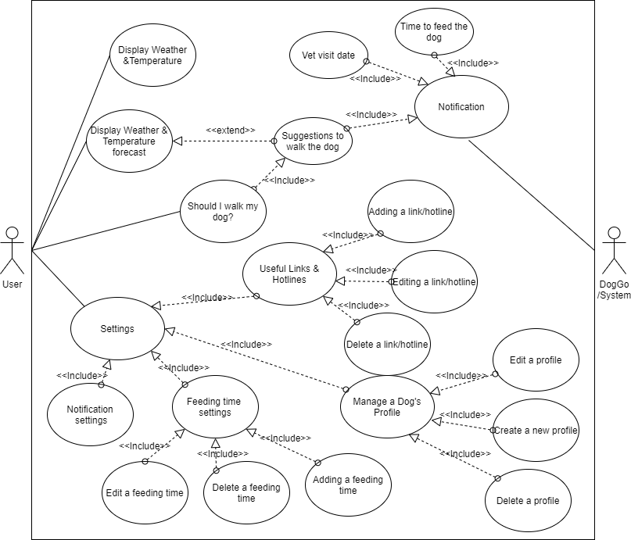

# 

# Use case Descriptions

|  |  |  |  |
| --- | --- | --- | --- |
| **Use Case ID:** | 01 | | |
| **Use Case Name:** | Display Weather forecast | | |
| **Created By:** |  | **Last Updated By:** |  |
| **Date Created:** | 21 August 2020 | **Date Last Updated:** | 21 August 2020 |

|  |  |
| --- | --- |
| **Actor:** | User |
| **Description:** | The feature displays the history and forecast of weather for the user |
| **Preconditions:** | User clicks the Weather button |
| **Postconditions:** | User click back button or exits the app |
| **Priority:** |  |
| **Frequency of Use:** |  |
| **Flow of Events:** | System will get the current date and time  System will search the api for the weather forecast 2hours before and after the current data and time  System will display the weather forecast 2hours before and after |
| **Alternative Flows:** |  |
| **Exceptions:** |  |
| **Includes:** |  |
| **Special Requirements:** |  |
| **Assumptions:** |  |
| **Notes and Issues:** |  |

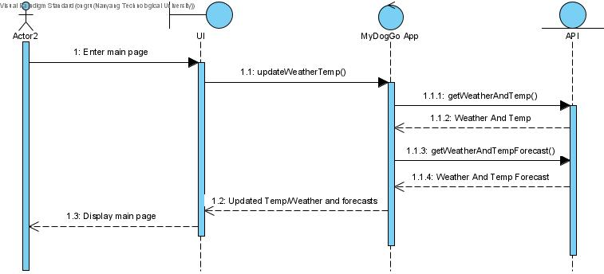

|  |  |  |  |
| --- | --- | --- | --- |
| **Use Case ID:** | 02 | | |
| **Use Case Name:** | Display Temperature forecast | | |
| **Created By:** |  | **Last Updated By:** |  |
| **Date Created:** | 21 August 2020 | **Date Last Updated:** | 21 August 2020 |

|  |  |
| --- | --- |
| **Actor:** | User |
| **Description:** | The feature displays the history and forecast of temperature for the user |
| **Preconditions:** |  |
| **Postconditions:** | User click back button or exits the app |
| **Priority:** |  |
| **Frequency of Use:** |  |
| **Flow of Events:** | User will click on the display temperature information  System will get the current date and time  System will search the api for the temperature forecast 2hours before and after the current data and time  System will display the temperature forecast 2hours before and after |
| **Alternative Flows:** |  |
| **Exceptions:** |  |
| **Includes:** |  |
| **Special Requirements:** |  |
| **Assumptions:** |  |
| **Notes and Issues:** |  |



|  |  |  |  |
| --- | --- | --- | --- |
| **Use Case ID:** | 03 | | |
| **Use Case Name:** | Suggestions to walk the dog (User manual check) | | |
| **Created By:** |  | **Last Updated By:** |  |
| **Date Created:** | 21 August 2020 | **Date Last Updated:** | 21 August 2020 |

|  |  |
| --- | --- |
| **Actor:** | User |
| **Description:** | The feature helps the user to check whether the temperature and weather is suitable for the user to walk his/her dog |
| **Preconditions:** | User click the suggest button  The time is within the range of user specification  The weather and temperature is fine |
| **Postconditions:** | User exits the application |
| **Priority:** |  |
| **Frequency of Use:** | Whenever the user clicks |
| **Flow of Events:** | User will click on the “Should I walk my dog now?”  System will get the current date and time  System will search the api for the temperature & weather forecast 2hours before and after the current data and time  System will then check if the temperature and weather satisfy the condition  If the conditions are satisfy, it will inform that the owner should walk his/her dog  It will also display the temperature and weather information |
| **Alternative Flows:** | If the temperature and weather does not satisfy the conditions, it will inform the owner not to his walk dog  System will suggest an alternative timing based on the forecasts |
| **Exceptions:** |  |
| **Includes:** |  |
| **Special Requirements:** |  |
| **Assumptions:** |  |
| **Notes and Issues:** |  |

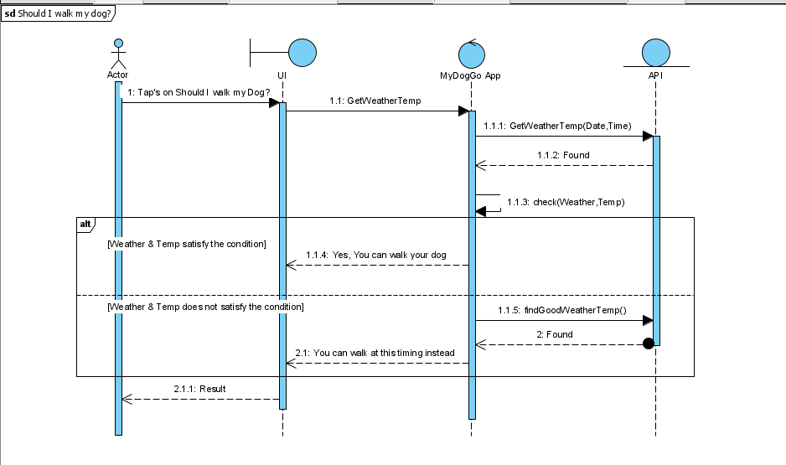

|  |  |  |  |
| --- | --- | --- | --- |
| **Use Case ID:** | 04 | | |
| **Use Case Name:** | Notification to walk the dog (System generated) | | |
| **Created By:** |  | **Last Updated By:** |  |
| **Date Created:** | 21 August 2020 | **Date Last Updated:** | 21 August 2020 |

|  |  |
| --- | --- |
| **Actor:** | System |
| **Description:** | Notification to suggest user to walk their dog |
| **Preconditions:** | The weather and temperature is fine  The time is not within the “do not disturb” time |
| **Postconditions:** | User know whether he should walk his dog or not |
| **Priority:** |  |
| **Frequency of Use:** | Daily |
| **Flow of Events:** | System will then check whether the weather and temperature is appropriate or not  If it is appropriate, the system will send a notification to the user |
| **Alternative Flows:** | If the weather and temperature is not appropriate, the system does nothing. |
| **Exceptions:** |  |
| **Includes:** |  |
| **Special Requirements:** |  |
| **Assumptions:** |  |
| **Notes and Issues:** |  |

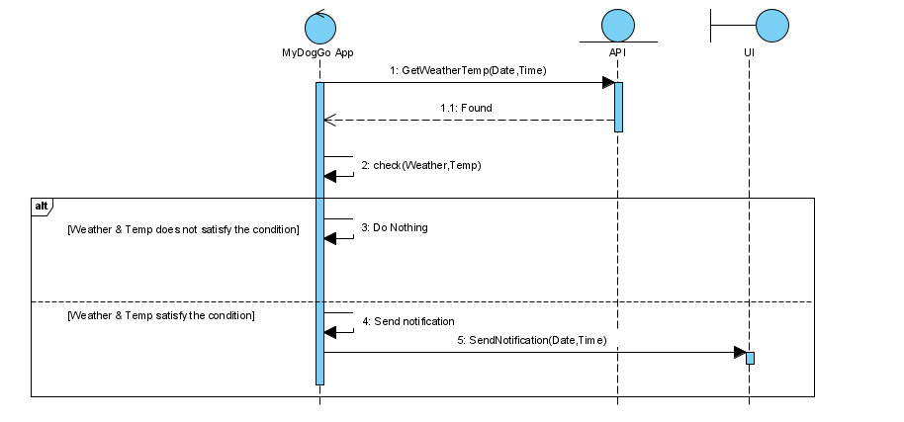

|  |  |  |  |
| --- | --- | --- | --- |
| **Use Case ID:** | 05 | | |
| **Use Case Name:** | Notification to bring to vet (System generated) | | |
| **Created By:** |  | **Last Updated By:** |  |
| **Date Created:** | 21 August 2020 | **Date Last Updated:** | 21 August 2020 |

|  |  |
| --- | --- |
| **Actor:** | System |
| **Description:** | Notification to remind user to bring pet to the vet |
| **Preconditions:** | Current date is same as user’s preferred choice of date of visiting the vet |
| **Postconditions:** | Notification clears after xx seconds  User clears notification |
| **Priority:** |  |
| **Frequency of Use:** | Annually |
| **Flow of Events:** | User sets date and time to visit vet  System sends notification on the day of visit |
| **Alternative Flows:** |  |
| **Exceptions:** |  |
| **Includes:** |  |
| **Special Requirements:** |  |
| **Assumptions:** |  |
| **Notes and Issues:** |  |

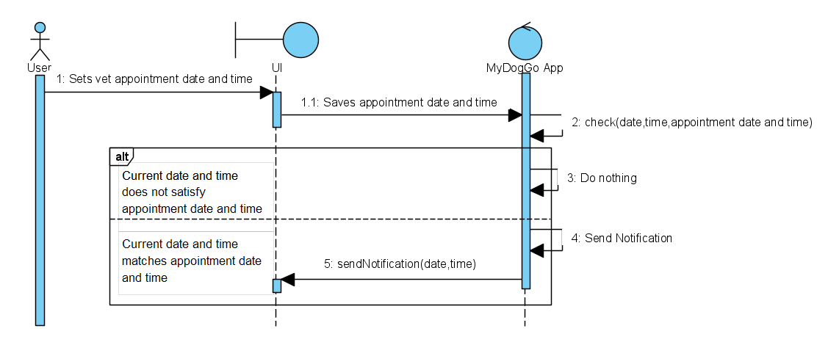

|  |  |  |  |
| --- | --- | --- | --- |
| **Use Case ID:** | 06 | | |
| **Use Case Name:** | Notification to feed (System generated) | | |
| **Created By:** |  | **Last Updated By:** |  |
| **Date Created:** | 21 August 2020 | **Date Last Updated:** | 21 August 2020 |

|  |  |
| --- | --- |
| **Actor:** | System |
| **Description:** | Sends notification to bring pet to feed |
| **Preconditions:** | User’s preferred timing to feed the dog |
| **Postconditions:** | Notification clears after xx seconds  User clears notification |
| **Priority:** |  |
| **Frequency of Use:** | Depending on feeding time settings |
| **Flow of Events:** | User sets timing to feed the pet  System sends notification when the time is met |
| **Alternative Flows:** |  |
| **Exceptions:** |  |
| **Includes:** |  |
| **Special Requirements:** |  |
| **Assumptions:** |  |
| **Notes and Issues:** |  |

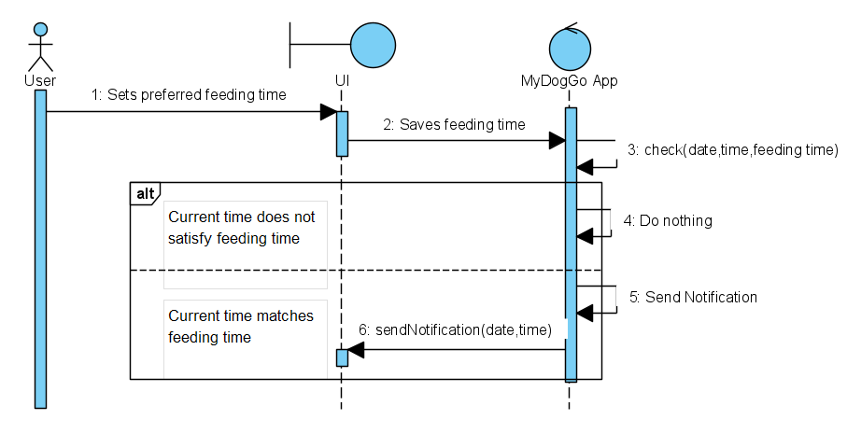

|  |  |  |  |
| --- | --- | --- | --- |
| **Use Case ID:** | 07 | | |
| **Use Case Name:** | Settings | | |
| **Created By:** |  | **Last Updated By:** |  |
| **Date Created:** | 21 August 2020 | **Date Last Updated:** | 21 August 2020 |

|  |  |
| --- | --- |
| **Actor:** | User |
| **Description:** | The settings is the place where use can change a list of settings such as Notification Settings, Dog Profile, Feeding Time, Vet Visit and Hotline & Links |
| **Preconditions:** |  |
| **Postconditions:** | - |
| **Priority:** |  |
| **Frequency of Use:** |  |
| **Flow of Events:** | User on the settings button  System will display list of settings to be changed   1. Notification Settings 2. Dog Profile 3. Feeding Time 4. Vet Visit 5. Hotline & Links   If the user selects the Notification Settings, he uses the Notification settings use case  If the user selects the Dog Profile, he uses the Managing of Dog Profile use case  If the user selects the Feeding Time, he uses Manage feeding time  If the user selects the Vet Visit, he uses the Manage vet visits use case  If the user selects the Hotline & Links, he uses the Useful links & Hotlines use case |
| **Alternative Flows:** |  |
| **Exceptions:** |  |
| **Includes:** |  |
| **Special Requirements:** |  |
| **Assumptions:** |  |
| **Notes and Issues:** |  |

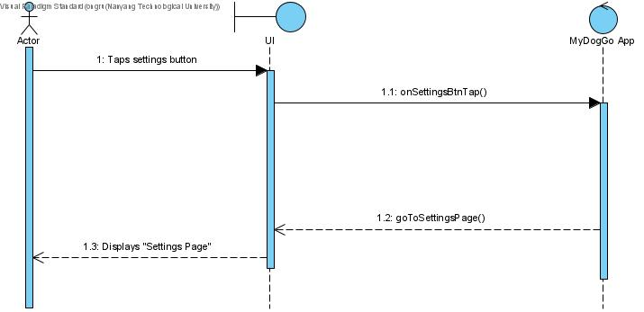

|  |  |  |  |
| --- | --- | --- | --- |
| **Use Case ID:** | 08 | | |
| **Use Case Name:** | Notification settings | | |
| **Created By:** |  | **Last Updated By:** |  |
| **Date Created:** | 21 August 2020 | **Date Last Updated:** | 21 August 2020 |

|  |  |
| --- | --- |
| **Actor:** | User |
| **Description:** | Allows the user to set when can notification appear |
| **Preconditions:** |  |
| **Postconditions:** | User successfully added the time  User press back or home button |
| **Priority:** |  |
| **Frequency of Use:** | Once in a lifetime |
| **Flow of Events:** | User clicks on the notification settings  User selects the time when to when should notification appear via dropdown menu  System will prompt the user to confirm the action  After the user confirm the action, the selected timing will be saved by the system |
| **Alternative Flows:** |  |
| **Exceptions:** |  |
| **Includes:** |  |
| **Special Requirements:** |  |
| **Assumptions:** |  |
| **Notes and Issues:** |  |

# 

|  |  |  |  |
| --- | --- | --- | --- |
| **Use Case ID:** | 09 | | |
| **Use Case Name:** | Managing of Dog Profile | | |
| **Created By:** |  | **Last Updated By:** |  |
| **Date Created:** | 21 August 2020 | **Date Last Updated:** | 21 August 2020 |

|  |  |
| --- | --- |
| **Actor:** | User |
| **Description:** | The feature helps to manage the profile of the dogs |
| **Preconditions:** | User clicks on the “Dog Profile” button |
| **Postconditions:** | User choose to exit using the back button |
| **Priority:** |  |
| **Frequency of Use:** |  |
| **Flow of Events:** | User will click on the “Manage My Dogs” button  System will then display current information about the dogs such as name, picture and etc  System will allow the user to Add, Delete or Edit profiles  If the user selects Add, he uses the ‘Adding of profile’ use case  If the user selects Delete, he uses the ‘Deleting of profile’ use case  If the user selects Edit, he uses the ‘Editing of profile’ use case |
| **Alternative Flows:** | If no profile exists, users will not be allowed to select Delete or Edit |
| **Exceptions:** |  |
| **Includes:** |  |
| **Special Requirements:** |  |
| **Assumptions:** |  |
| **Notes and Issues:** |  |

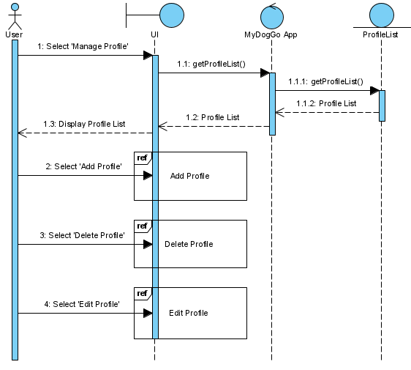

|  |  |  |  |
| --- | --- | --- | --- |
| **Use Case ID:** | 10 | | |
| **Use Case Name:** | Adding of Dog profile | | |
| **Created By:** |  | **Last Updated By:** |  |
| **Date Created:** | 21 August 2020 | **Date Last Updated:** | 21 August 2020 |

|  |  |
| --- | --- |
| **Actor:** | User |
| **Description:** | Upon clicking on ‘Add’ on the Dog Profile page, users will then follow the flow of events here |
| **Preconditions:** |  |
| **Postconditions:** | User has added a profile or user cancels the operation |
| **Priority:** |  |
| **Frequency of Use:** |  |
| **Flow of Events:** | User clicks on Add Profile  User inputs the information of the dog such as name and picture  User then clicks OK  System will prompt the user to confirm the action  After the user confirms the action, the newly created dog profile will be created and displayed |
| **Alternative Flows:** |  |
| **Exceptions:** |  |
| **Includes:** |  |
| **Special Requirements:** |  |
| **Assumptions:** |  |
| **Notes and Issues:** |  |

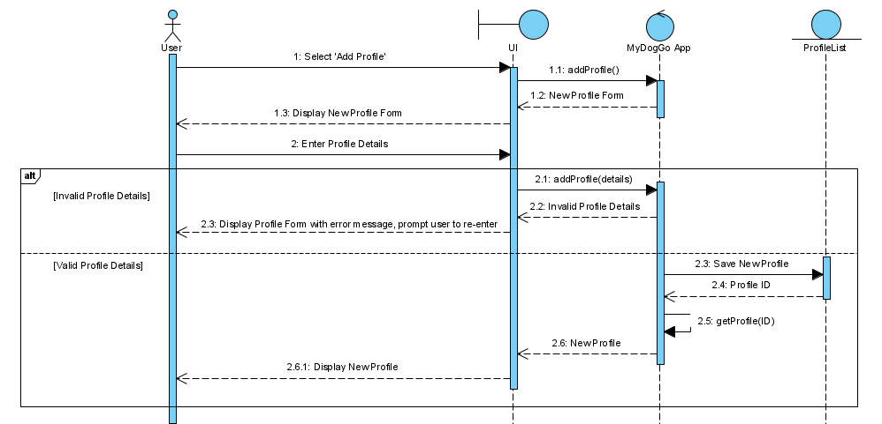

|  |  |  |  |
| --- | --- | --- | --- |
| **Use Case ID:** | 11 | | |
| **Use Case Name:** | Deleting of profile | | |
| **Created By:** |  | **Last Updated By:** |  |
| **Date Created:** | 21 August 2020 | **Date Last Updated:** | 21 August 2020 |

|  |  |
| --- | --- |
| **Actor:** | User |
| **Description:** | Upon clicking on ‘Delete’ on the profile page, users will then follow the flow of events here |
| **Preconditions:** | User has at least 1 profile |
| **Postconditions:** | User has deleted a profile or user cancels the operation |
| **Priority:** |  |
| **Frequency of Use:** |  |
| **Flow of Events:** | User clicks on Delete profile  User selects the profile to be deleted  System will prompt the user to confirm the action  After the user confirm the action, the selected dog profile will be deleted |
| **Alternative Flows:** |  |
| **Exceptions:** | If no profile exists, user will not be able to click on the Delete profile |
| **Includes:** |  |
| **Special Requirements:** |  |
| **Assumptions:** | There is at least one profile created |
| **Notes and Issues:** |  |

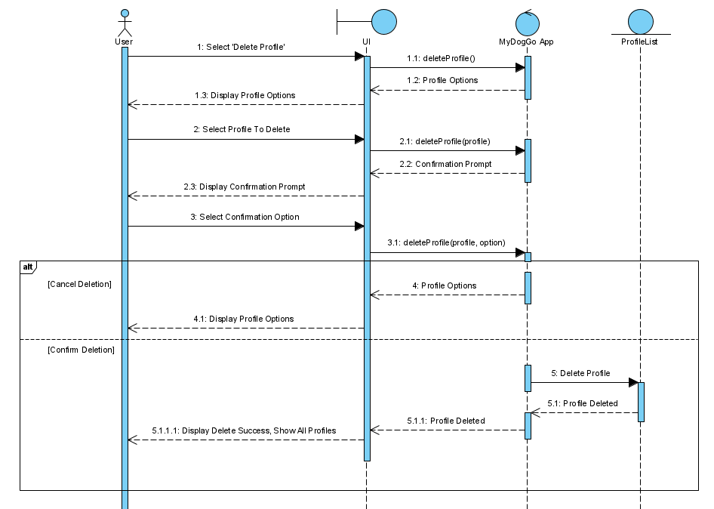

|  |  |  |  |
| --- | --- | --- | --- |
| **Use Case ID:** | 12 | | |
| **Use Case Name:** | Editing of profile | | |
| **Created By:** |  | **Last Updated By:** |  |
| **Date Created:** | 21 August 2020 | **Date Last Updated:** | 21 August 2020 |

|  |  |
| --- | --- |
| **Actor:** | User |
| **Description:** | Upon clicking on Edit at the profile page, users will then follow the flow of events here |
| **Preconditions:** | User clicks edit dog profile button |
| **Postconditions:** | After user has saved the changes by clicking confirm/ tick icon |
| **Priority:** |  |
| **Frequency of Use:** |  |
| **Flow of Events:** | User clicks on Edit profile  User selects the profile to be edited  System will display the selected profile  User then input the things to be edited  System will prompt the user to confirm the action  After user confirmed the action, the profile will then be edited |
| **Alternative Flows:** |  |
| **Exceptions:** |  |
| **Includes:** |  |
| **Special Requirements:** |  |
| **Assumptions:** | There already exists a profile |
| **Notes and Issues:** |  |

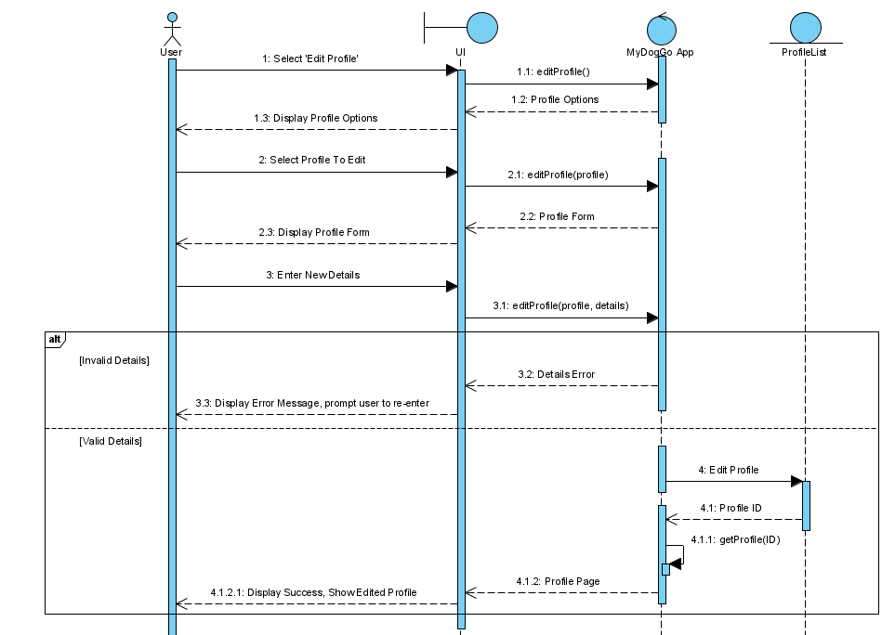

|  |  |  |  |
| --- | --- | --- | --- |
| **Use Case ID:** | 13 | | |
| **Use Case Name:** | Manage feeding time | | |
| **Created By:** |  | **Last Updated By:** |  |
| **Date Created:** | 21 August 2020 | **Date Last Updated:** | 21 August 2020 |

|  |  |
| --- | --- |
| **Actor:** | System |
| **Description:** | The feature helps to manage the feeding times of the dogs |
| **Preconditions:** | User clicks on manage feeding times button |
| **Postconditions:** | User choose to exit using the back button |
| **Priority:** |  |
| **Frequency of Use:** |  |
| **Flow of Events:** | User clicks on Feeding Time  System will display the current timings for feeding  User can then Add a timeDate, Delete a timeDate or edit a timeDate for feeding  If the user chooses to Add, he uses the Adding of feeding time use case  If the user chooses to Delete, he uses the Deleting of feeding time use case  If the user chooses to Edit, he uses the Editing of feeding time use case |
| **Alternative Flows:** |  |
| **Exceptions:** |  |
| **Includes:** |  |
| **Special Requirements:** |  |
| **Assumptions:** |  |
| **Notes and Issues:** |  |

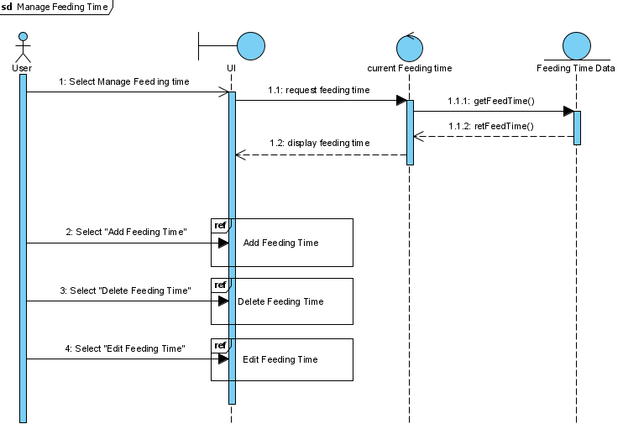

|  |  |  |  |
| --- | --- | --- | --- |
| **Use Case ID:** | 14 | | |
| **Use Case Name:** | Adding of feeding time | | |
| **Created By:** |  | **Last Updated By:** |  |
| **Date Created:** | 21 August 2020 | **Date Last Updated:** | 21 August 2020 |

|  |  |
| --- | --- |
| **Actor:** | System |
| **Description:** | Shows the flow of events when the user clicks add feeding time |
| **Preconditions:** | User clicks add feeding time |
| **Postconditions:** | User confirms feeding times |
| **Priority:** |  |
| **Frequency of Use:** |  |
| **Flow of Events:** | User clicks on Add feeding times  User selects the date and time for a feeding time  System will prompt the user to confirm the action  After the user confirm the action, the new feeding time will be added |
| **Alternative Flows:** |  |
| **Exceptions:** |  |
| **Includes:** |  |
| **Special Requirements:** |  |
| **Assumptions:** |  |
| **Notes and Issues:** |  |

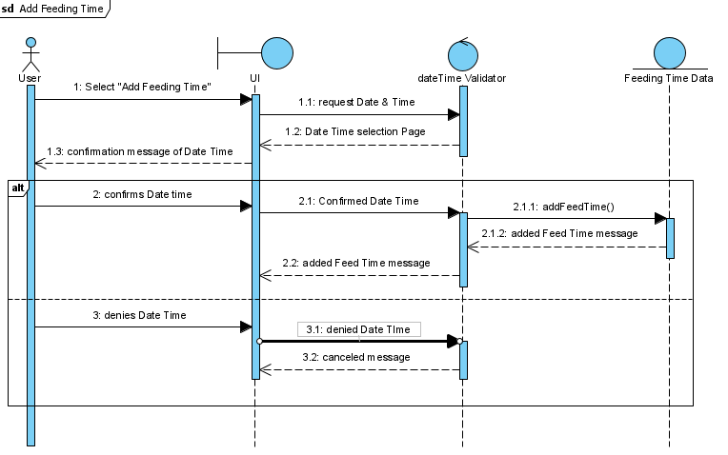

|  |  |  |  |
| --- | --- | --- | --- |
| **Use Case ID:** | 15 | | |
| **Use Case Name:** | Deleting of feeding times | | |
| **Created By:** |  | **Last Updated By:** |  |
| **Date Created:** | 21 August 2020 | **Date Last Updated:** | 21 August 2020 |

|  |  |
| --- | --- |
| **Actor:** | System |
| **Description:** | Shows the flow of events when the user clicks delete feeding time |
| **Preconditions:** | User clicks delete feeding time |
| **Postconditions:** | User confirms the deleted timings of feeding |
| **Priority:** |  |
| **Frequency of Use:** |  |
| **Flow of Events:** | User clicks on Delete feeding times  User selects the feeding times to be deleted  System will prompt the user to confirm the action  After the user confirm the action, the selected feeding time will be deleted |
| **Alternative Flows:** |  |
| **Exceptions:** |  |
| **Includes:** |  |
| **Special Requirements:** |  |
| **Assumptions:** |  |
| **Notes and Issues:** |  |

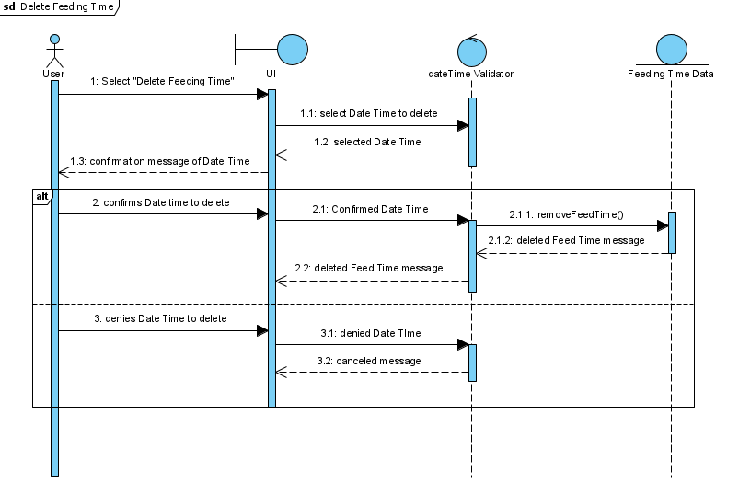

|  |  |  |  |
| --- | --- | --- | --- |
| **Use Case ID:** | 16 | | |
| **Use Case Name:** | Editing of feeding time | | |
| **Created By:** |  | **Last Updated By:** |  |
| **Date Created:** | 21 August 2020 | **Date Last Updated:** | 21 August 2020 |

|  |  |
| --- | --- |
| **Actor:** | System |
| **Description:** | Shows the flow of events when the user clicks edit feeding times |
| **Preconditions:** | User clicks edit feeding times |
| **Postconditions:** | User confirms changes of feeding times |
| **Priority:** |  |
| **Frequency of Use:** |  |
| **Flow of Events:** | User clicks on Edit feeding times  User selects the feeding times to be edited  System will prompt the user to confirm the action  After the user confirm the action, the selected feeding time changes will be made. |
| **Alternative Flows:** |  |
| **Exceptions:** |  |
| **Includes:** |  |
| **Special Requirements:** |  |
| **Assumptions:** |  |
| **Notes and Issues:** |  |

# 

|  |  |  |  |
| --- | --- | --- | --- |
| **Use Case ID:** | 17 | | |
| **Use Case Name:** | Manage vet visits | | |
| **Created By:** |  | **Last Updated By:** |  |
| **Date Created:** | 21 August 2020 | **Date Last Updated:** | 21 August 2020 |

|  |  |
| --- | --- |
| **Actor:** | System |
| **Description:** | The feature helps to manage vet visits |
| **Preconditions:** | User clicks on the manage vet visits button |
| **Postconditions:** | User choose to exit using the back button |
| **Priority:** |  |
| **Frequency of Use:** |  |
| **Flow of Events:** | User clicks on doggo vet visit settings  System will display the current timings for vet visits  User can then Add a timeDate, Delete a timeDate or edit a timeDate for vet visits  If the user chooses to Add, he uses the Adding of a vet visit use case  If the user chooses to Delete, he uses the Deleting of a vet visit use case  If the user chooses to Edit, he uses the Editing of a vet visit use case |
| **Alternative Flows:** |  |
| **Exceptions:** |  |
| **Includes:** |  |
| **Special Requirements:** |  |
| **Assumptions:** |  |
| **Notes and Issues:** |  |

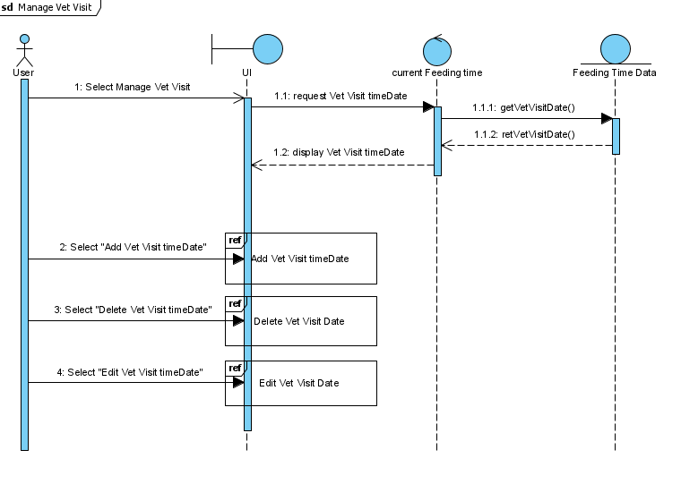

|  |  |  |  |
| --- | --- | --- | --- |
| **Use Case ID:** | 18 | | |
| **Use Case Name:** | Adding of a vet visit time | | |
| **Created By:** |  | **Last Updated By:** |  |
| **Date Created:** | 21 August 2020 | **Date Last Updated:** | 21 August 2020 |

|  |  |
| --- | --- |
| **Actor:** | System |
| **Description:** | Shows the flow of events when the user clicks add vet visit |
| **Preconditions:** | User clicks add vet visit |
| **Postconditions:** | User confirms visit time  Use chooses to exit using the back button |
| **Priority:** |  |
| **Frequency of Use:** |  |
| **Flow of Events:** | User clicks on Add vet visit  User selects the date and time for a vet visit  System will prompt the user to confirm the action  After the user confirm the action, the new vet visit will be added |
| **Alternative Flows:** |  |
| **Exceptions:** |  |
| **Includes:** |  |
| **Special Requirements:** |  |
| **Assumptions:** |  |
| **Notes and Issues:** |  |

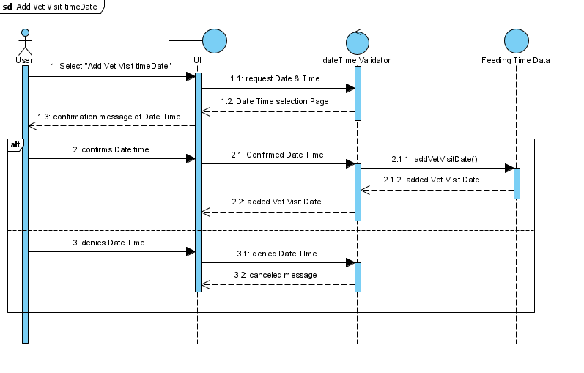

|  |  |  |  |
| --- | --- | --- | --- |
| **Use Case ID:** | 19 | | |
| **Use Case Name:** | Deleting of a vet visit | | |
| **Created By:** |  | **Last Updated By:** |  |
| **Date Created:** | 21 August 2020 | **Date Last Updated:** | 21 August 2020 |

|  |  |
| --- | --- |
| **Actor:** | System |
| **Description:** | Shows the flow of events when the user clicks deleting vet visits |
| **Preconditions:** | User clicks delete vet visit |
| **Postconditions:** | User confirms the deleted vet visit |
| **Priority:** |  |
| **Frequency of Use:** |  |
| **Flow of Events:** | User clicks on Delete vet visit  User selects thevet visit to be deleted  System will prompt the user to confirm the action  After the user confirm the action, the selected vet visit will be deleted |
| **Alternative Flows:** |  |
| **Exceptions:** |  |
| **Includes:** |  |
| **Special Requirements:** |  |
| **Assumptions:** |  |
| **Notes and Issues:** |  |

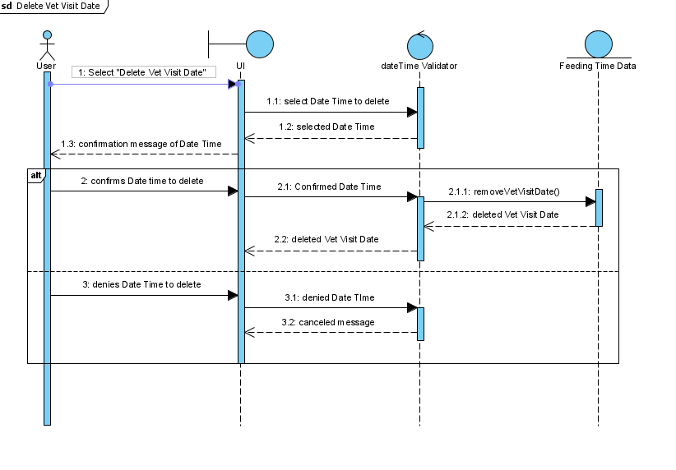

|  |  |  |  |
| --- | --- | --- | --- |
| **Use Case ID:** | 20 | | |
| **Use Case Name:** | Editing of vet visits | | |
| **Created By:** |  | **Last Updated By:** |  |
| **Date Created:** | 21 August 2020 | **Date Last Updated:** | 21 August 2020 |

|  |  |
| --- | --- |
| **Actor:** | System |
| **Description:** | Shows the flow of events when the user clicks edit vet visits |
| **Preconditions:** | User clicks edit vet visits |
| **Postconditions:** | User confirms changes of a vet visit Use chooses to exit via the back button |
| **Priority:** |  |
| **Frequency of Use:** |  |
| **Flow of Events:** | User clicks on Edit vet visits  User selects the vet visit to be edited  System will prompt the user to confirm the action  After the user confirm the action, the selected vet visit changes will be made. |
| **Alternative Flows:** |  |
| **Exceptions:** |  |
| **Includes:** |  |
| **Special Requirements:** |  |
| **Assumptions:** |  |
| **Notes and Issues:** |  |

# 

|  |  |  |  |
| --- | --- | --- | --- |
| **Use Case ID:** | 21 | | |
| **Use Case Name:** | Useful links & Hotlines | | |
| **Created By:** |  | **Last Updated By:** |  |
| **Date Created:** | 21 August 2020 | **Date Last Updated:** | 21 August 2020 |

|  |  |
| --- | --- |
| **Actor:** | User |
| **Description:** | Shows the flow of events when the user clicks on the useful links & Hotlines |
| **Preconditions:** |  |
| **Postconditions:** | User received the links and/or hotlines they required |
| **Priority:** |  |
| **Frequency of Use:** |  |
| **Flow of Events:** | User clicks on Links & Hotlines  System will display suggested links and hotlines as well as user inputs  User can then Add a link/hotline, Delete a link/hotline or edit a link/hotline  If the user chooses to Add, he uses the Adding of link & hotline use case  If the user chooses to Delete, he uses the Deleting of link & hotline use case  If the user chooses to Edit, he uses the Adding of link & hotline use case |
| **Alternative Flows:** |  |
| **Exceptions:** |  |
| **Includes:** |  |
| **Special Requirements:** |  |
| **Assumptions:** |  |
| **Notes and Issues:** |  |

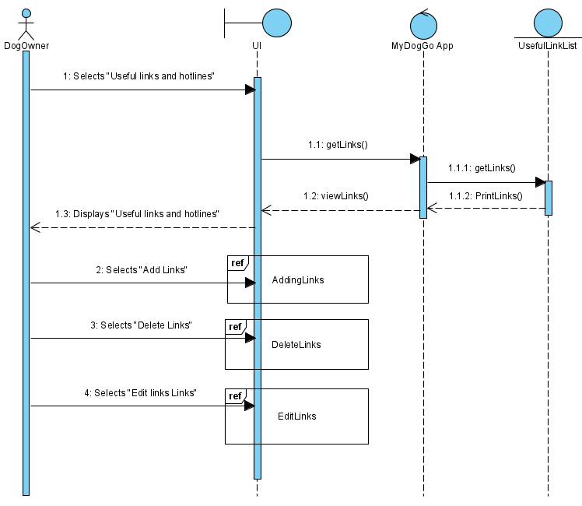

|  |  |  |  |
| --- | --- | --- | --- |
| **Use Case ID:** | 22 | | |
| **Use Case Name:** | Adding of useful links & hotlines | | |
| **Created By:** |  | **Last Updated By:** |  |
| **Date Created:** | 21 August 2020 | **Date Last Updated:** | 21 August 2020 |

|  |  |
| --- | --- |
| **Actor:** | User |
| **Description:** | Shows the flow of events when the user clicks add useful links & hotlines |
| **Preconditions:** | User clicks add link |
| **Postconditions:** | User confirms added links & hotlines |
| **Priority:** |  |
| **Frequency of Use:** |  |
| **Flow of Events:** | User clicks on Add Links & Hotline Button  User inputs the links & hotlines as well as their description of it  User then clicks OK  System will prompt the user to confirm the action  After the user confirm the action, the newly created links and hotline will be displayed |
| **Alternative Flows:** |  |
| **Exceptions:** |  |
| **Includes:** |  |
| **Special Requirements:** |  |
| **Assumptions:** |  |
| **Notes and Issues:** |  |

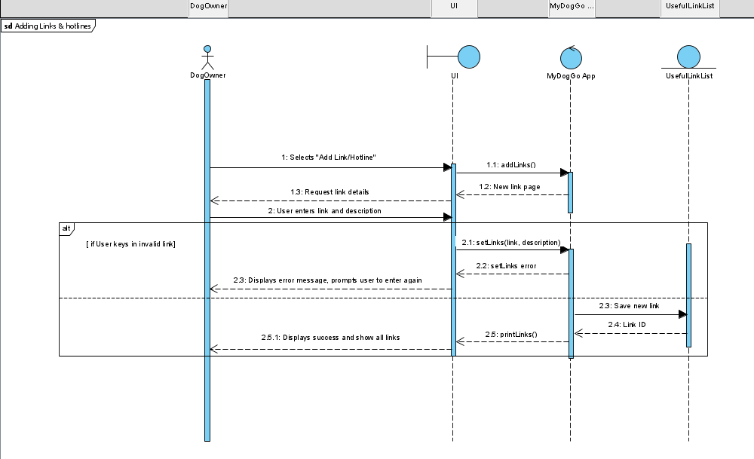

|  |  |  |  |
| --- | --- | --- | --- |
| **Use Case ID:** | 23 | | |
| **Use Case Name:** | Deleting of useful links & hotlines | | |
| **Created By:** |  | **Last Updated By:** |  |
| **Date Created:** | 21 August 2020 | **Date Last Updated:** | 21 August 2020 |

|  |  |
| --- | --- |
| **Actor:** | Dog owner |
| **Description:** | Shows the flow of events when the user clicks delete useful links & Hotlines |
| **Preconditions:** | User has at least one link or hotline |
| **Postconditions:** | User deleted the links or hotlines they selected |
| **Priority:** |  |
| **Frequency of Use:** |  |
| **Flow of Events:** | User clicks on Delete link & hotlines  User selects the link or hotlines to be deleted  System will prompt the user to confirm the action  After the user confirm the action, the selected link or hotline will be deleted |
| **Alternative Flows:** | If there are no links or hotlines, the delete button will not be shown |
| **Exceptions:** |  |
| **Includes:** |  |
| **Special Requirements:** |  |
| **Assumptions:** | There already exists a link/hotline |
| **Notes and Issues:** |  |

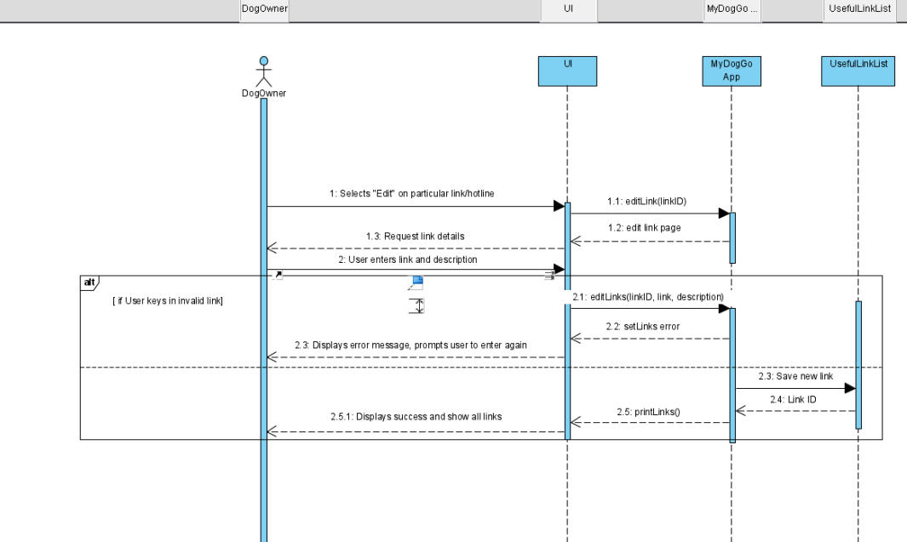

|  |  |  |  |
| --- | --- | --- | --- |
| **Use Case ID:** | 24 | | |
| **Use Case Name:** | Editing of useful links & hotlines | | |
| **Created By:** |  | **Last Updated By:** |  |
| **Date Created:** | 21 August 2020 | **Date Last Updated:** | 21 August 2020 |

|  |  |
| --- | --- |
| **Actor:** | Dog owner |
| **Description:** | Shows the flow of events when the user clicks edit useful links & Hotlines |
| **Preconditions:** | User clicks edit link |
| **Postconditions:** | User edited the links and/or hotlines they required |
| **Priority:** |  |
| **Frequency of Use:** |  |
| **Flow of Events:** | User clicks on Edit  User selects the links or hotlines to be edited  System will display the selected links or hotlines  User then input the things to be edited  System will prompt the user to confirm the action  After user confirmed the action, the links or hotlines will then be edited |
| **Alternative Flows:** |  |
| **Exceptions:** |  |
| **Includes:** |  |
| **Special Requirements:** |  |
| **Assumptions:** | There already exists a link/hotline |
| **Notes and Issues:** |  |

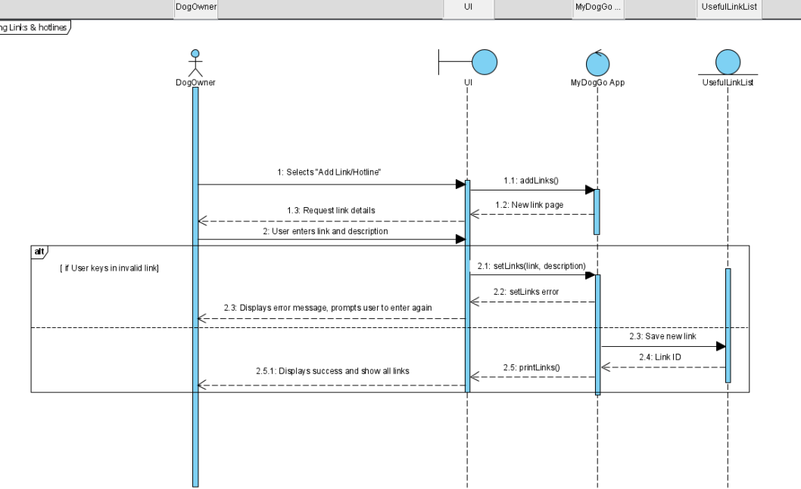

# UI Mock Up

